Requesting Permission to Use Figures/Tables from Journals

To publish a figure/table that you have not created to eXtension.org, permission must be obtained from the copyright holder. Some journals (e.g. nature publications) will not charge fees to post figures/tables provided they are used for education purposes and/or by a non-profit. Articles created for eXtension meet both of these criteria. Unfortunately every publisher seems to do things differently. General guidelines are provided below. If you have questions, please contact Heather Merk (merk.9@osu.edu).

Requesting Permission
- Locate the full-text version of the article on the publisher’s website.
- Most journals will have a “rights and permissions” radio button to click on (see green rectangle on images below)

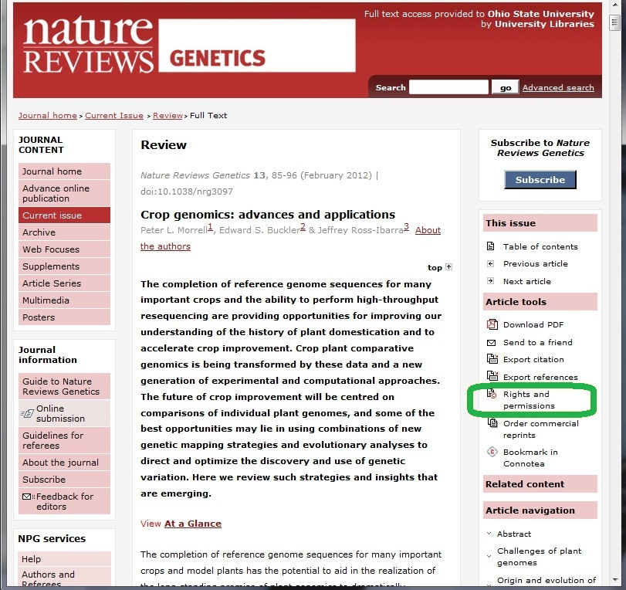

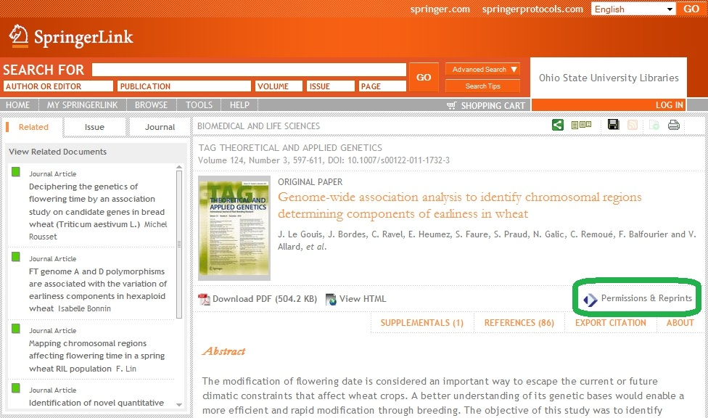

- After clicking on the rights and permissions radio button, you will typically need to fill out a permission request (see images below). Many journals (e.g. nature publications) use the Copyright Clearance Center’s Rightslink service to handle their permission requests. If you don’t already have a free account, you will need to create one.
- Points to consider when filling out permission requests:
  - Content will be posted on the Internet at www.extension.org
  - Content will be publicly available
  - Content will be used in non-commercial/non-profit/educational setting
- Some journals grant immediate permission for non-commercial use, while others take several weeks to obtain.
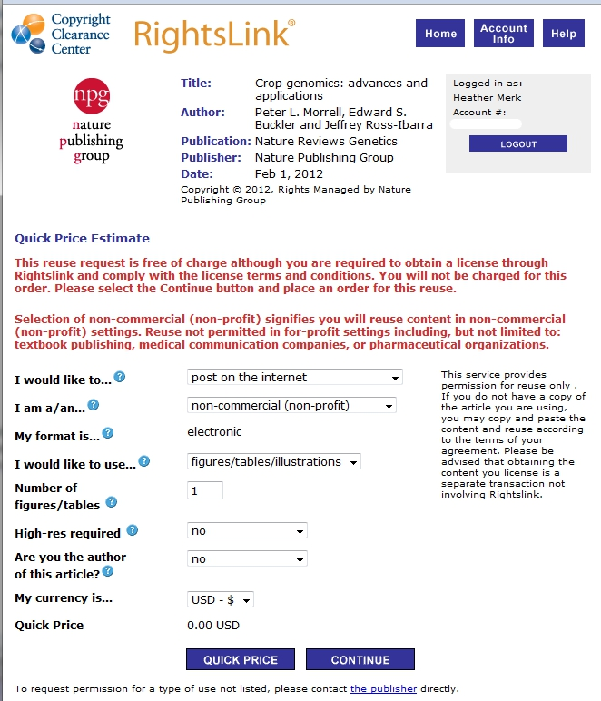

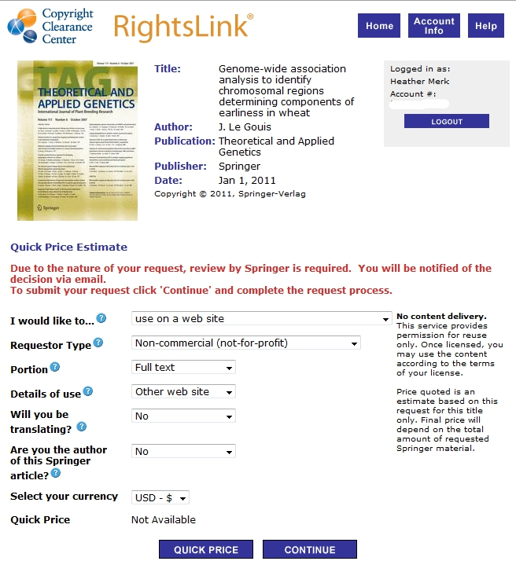

After You Have Been Granted Permission
- Provide a copy of the permission text to Heather Merk (merk.9@osu.edu). This permission text is required prior to publication at eXtension.org. Sometimes the permission text is provided in a nice pdf format, but other times you will need to copy and paste the text from a webpage or take screenshots of the webpage.

